IMAT3451 Final Year Project Periodic Progress Report
Programme/Course Title: G40051 Computer Science BSc(Hons)

Name: Mohit Gautam Assessment Period:

Project Title: Table4Me app Report Number:11/10/17-18/10/17
_______________________________________________________________________

Objectives for Period: (refer to previous report)
Some of the objectives for this period are:
- To have second one to one meeting with my supervisor.
- To ask for help if needed to complete my project contract/ethical/global/BSc forms.
- To think of a App name.
- To Finish off Gantt chart using one of the Gantt chart software.

Summary of Progress for Period: (identify evidence of progress)
- During the meeting with my supervisor, I shared some ideas of what my apps name will be, and he recommended me with some really good names and I finalised with the name ‘Table4Me’.
- During the period I have start learning basic features of android studio and I managed to create a simple app which outputs ‘Hello world’.
- I finished my Gantt chart using the Gantt chart software.

Problem Areas and Suggested Solutions:

- I had issue with my Gantt chart software as I was struggling to use the software, however my supervisor who was familiar with the software helped me to solve this issue .
- I was late for my one to one meeting as my train was delayed, so I had less time to talk to my supervisor for my progress over the project, however to overcome this problem, I emailed my supervisor who explained the topics which I was unable to cover in short amount of time.

________________________________________________________________________

Objectives, Deliverables & Plan for Next Period:

- to attend second group meeting with my supervisor.
- to complete all of the four forms and send it to my supervisor for a feedback.
- to start looking at the literature review and requirements, as it will be due soon.
- to send off all of the four signed forms.

Date of Next Review:25/10/17
________________________________________________________________________
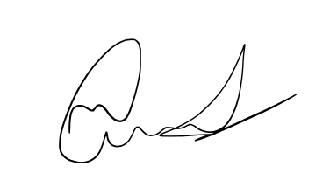

Student’s Signature: Date:

Supervisor’s Signature: Date:25/10/17

